SECTION – 2

DIGITAL LOGIC CIRCUITS

Session 1

Ex 1: Design and implement the Exclusive-OR gate using AND, OR and NOT gates.

Ans:
Step 1:
Circuit specification:-
Exclusive or is a combinational circuit the Forms the ex-or operation on the two input values x and y.

Input: Two bits (A, B)
Output: Output= A (+) B

Step 2: Truth Table

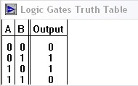

Step 3: Minterm t= F1 (1, 2)

Step 4: Karnaugh maps

0 | 1
1

Step5: expression
Output = A (+) B

Step 6: Circuit
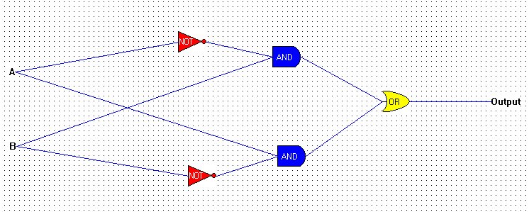

Ex 2: Design an “Alarm circuit” using only OR gate in which, if ‘doors’ OR ‘windows’ Or ‘Fire alarm’ is activated and then alarm sound should start.

Ans:

Step1: Specification
Alarm circuit is a combination circuit that forms output a if ‘doors’ OR ‘windows’ Or ‘Fire alarm’ are activated by setting the corresponding bit 1.
Input: 3 input bits (‘d’,’w’,’f’)
Output: 1 bit

Step2: Truth table

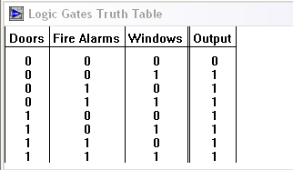

Step 3: identifying Minterms
Output= f+d+w

Step 4: K-map

0 | 1 | 1 | 1
1 | 1 | 1 | 1
Step5: Expression
Output= f+d+w

Step6: Circuit
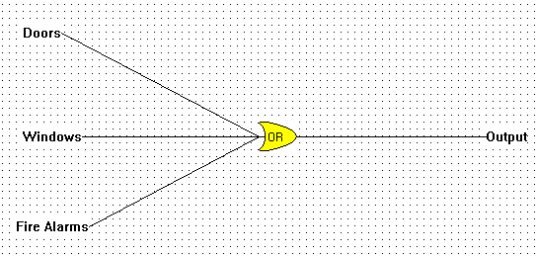

Ex 3: We know NAND gate is universal gate but we need proof, so Design other gates like OR, NOR, AND and NOT using only NAND gates.

Ans:

(A) NOT gate using NAND

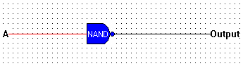

(B)AND gate using NAND

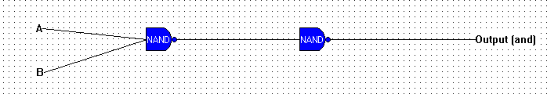

(C) OR gate using NAND

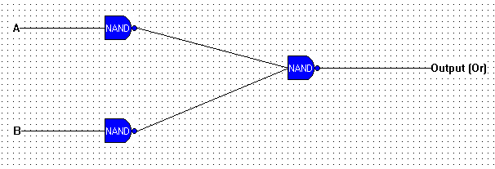

(D) NOR gate using NAND

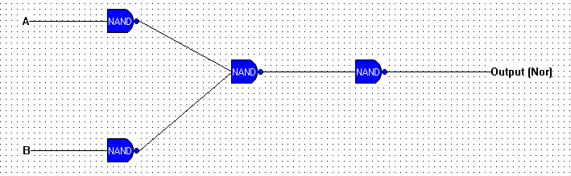

Ex 4: Design a digital circuit whose output is equal to 1 if the majority of inputs are 1’s . The output is 0 otherwise.

Ans:

Step1: Specification
Digital circuit whose output is equal to 1 if the majority of inputs are 1’s The output is 0 otherwise.
Inputs: 4 bits (a, b, c, d)
Output: 1 bit

Step2: Truth Table

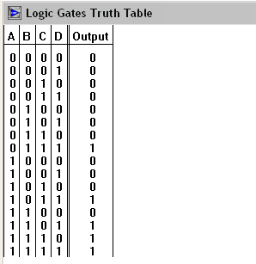

Step 3: Minterms
Output = F (13, 14, 15)

Step4: K-map

0 | 0 | 0 | 0
0 | 0 | 1 | 0
0 | 1 | 1 | 1
0 | 0 | 1 | 0

Step 5: expression
Output = abc+abd+bcd+acd

Step6: Circuit
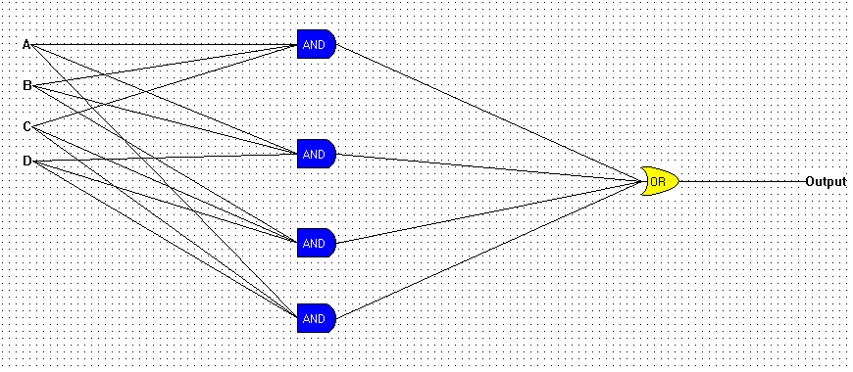

Ex 5: Design the following digital circuit
Ans:

- Half adder
A half adder circuit takes 2 binary input and gives its sum. The input is 2 bits are a and b the outputs are its sum and carry.

Step 1: Specification
Inputs: 2 bits
Outputs: Sum and Carry

Step2: Circuit and Truth table

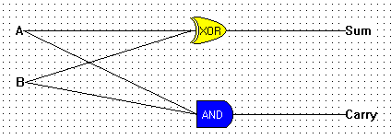

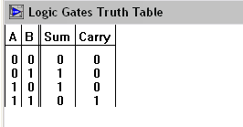

- Half Subtractor
A half subtractor circuit takes 2 binary input and gives its difference. The input is 2 bits are a and b the outputs are its difference and borrow

Step 1: Specification
Input: 2 bits
Output: Difference and Borrow

Step 2: Circuit and Truth table

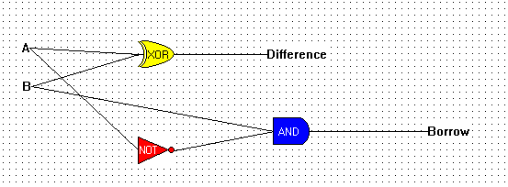

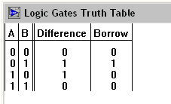

- Full Subtractor
A full subtractor is a combinational circuit that performs a subtraction between two bits taking into account that a one may be borrowed by a lower significant bit, the circuit has 3 inputs A, B and C. and 2 outputs Difference and Borrow.

Step1. Specification
Inputs: A, B and C
Outputs: Difference and Borrow

Step2: Circuit and truth table

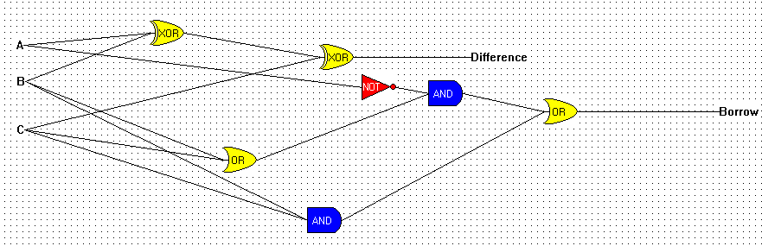

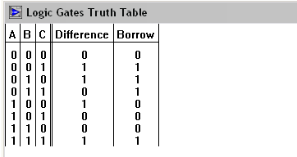

Ex 7: Design a combinational circuit that takes 3-bit number and the output of that circuit should be the square of the input.
Ans:
Step1: Specification

Square of the number is a combinational circuit that can be obtained by taking 3 bits inputs and 6 bit outputs.

Step 2: Truth table

A | B | C | O1 | O2 | O3 | O4 | O5 | O6
0 | 0 | 0 | 0 | 0 | 0 | 0 | 0 | 0
0 | 0 | 1 | 0 | 0 | 0 | 0 | 0 | 1
0 | 1 | 0 | 0 | 0 | 0 | 1 | 0 | 0
0 | 1 | 1 | 0 | 0 | 1 | 0 | 0 | 1
1 | 0 | 0 | 0 | 1 | 0 | 0 | 0 | 0
1 | 0 | 1 | 0 | 1 | 1 | 0 | 0 | 1
1 | 1 | 0 | 1 | 0 | 0 | 1 | 0 | 0
1 | 1 | 1 | 1 | 1 | 0 | 0 | 0 | 1

Step 3: Identifying Minterms

O1=F1 (6, 7)
O2=F2 (4, 5, 7)
O3=F3 (3, 5)
O4=F4 (2, 6)
O5=0
O6=F6 (1, 3, 5, 7)

The Boolean functions for the three inputs and 6 outputs are derived as follows:-

For F1 (6, 7)
O1=AB

For F2 (4, 5, 7)
O2=AB`+AC

For F3 (3, 7)
O3=A`BC+AB`C

For F4 (2, 6)
O4=BC`

For F6 (1, 3, 5, 7)
O6=C

Step4: Circuit

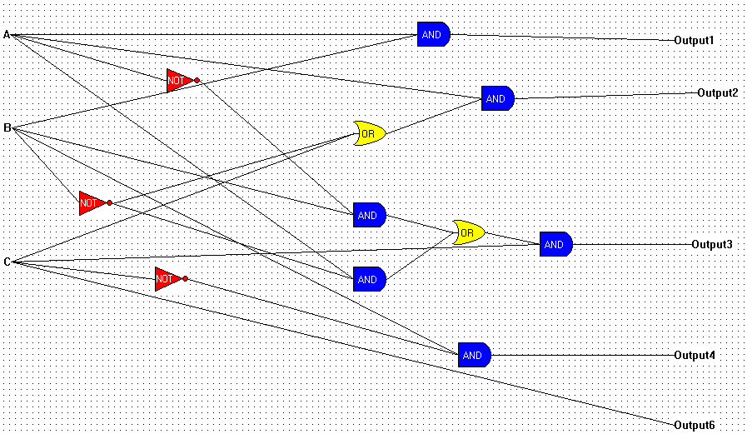

Ex 8: Design a combinational circuit where input is a 4 bit number and output is it’s 2’s complement.
Ans: Step1:
Inputs= A, B, C, D
Output=Q1, Q2, Q3, Q4 (2’s complement)

Step2: Truth table
A | B | C | D | Q1 | Q2 | Q3 | Q4
0 | 0 | 0 | 0 | 0 | 0 | 0 | 0
0 | 0 | 0 | 1 | 1 | 1 | 1 | 1
0 | 0 | 1 | 0 | 1 | 1 | 1 | 0
0 | 0 | 1 | 1 | 1 | 1 | 0 | 1
0 | 1 | 0 | 0 | 1 | 1 | 0 | 0
0 | 1 | 0 | 1 | 1 | 0 | 1 | 1
0 | 1 | 1 | 0 | 1 | 0 | 1 | 0
0 | 1 | 1 | 1 | 1 | 0 | 0 | 1
1 | 0 | 0 | 0 | 1 | 0 | 0 | 0
1 | 0 | 0 | 1 | 0 | 1 | 1 | 1
1 | 0 | 1 | 0 | 0 | 1 | 1 | 0
1 | 1 | 0 | 0 | 0 | 1 | 0 | 0
1 | 1 | 0 | 1 | 0 | 0 | 1 | 1
1 | 1 | 1 | 0 | 0 | 0 | 1 | 0
1 | 1 | 1 | 1 | 0 | 0 | 0 | 1
Step3: K-map

Q1=A`D+A`C+A`BC`+AB`C`D`
Q2=BC`D`+B`D+B`C
Q3=C`D+CD`
Q4=D

Step 4: Circuit

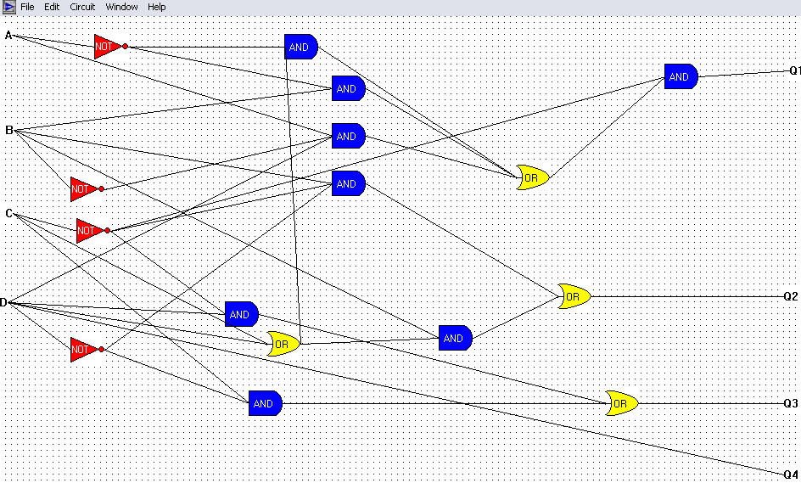

Ex 9: Design an encoder circuit, which will convert decimal number to binary.

Ans:
An encoder is a circuit that encodes a particular input to a different format.
A Decimal to binary encoder constructed below

Truth table:

D0 | D1 | D2 | D3 | D4 | D5 | D6 | D7 | D8 | D9 | O1 | O2 | O3 | O4
1 | 0 | 0 | 0 | 0 | 0 | 0 | 0 | 0 | 0 | 0 | 0 | 0 | 0
0 | 1 | 0 | 0 | 0 | 0 | 0 | 0 | 0 | 0 | 0 | 0 | 0 | 1
0 | 0 | 1 | 0 | 0 | 0 | 0 | 0 | 0 | 0 | 0 | 0 | 1 | 0
0 | 0 | 0 | 1 | 0 | 0 | 0 | 0 | 0 | 0 | 0 | 0 | 1 | 1
0 | 0 | 0 | 0 | 1 | 0 | 0 | 0 | 0 | 0 | 0 | 1 | 0 | 0
0 | 0 | 0 | 0 | 0 | 1 | 0 | 0 | 0 | 0 | 0 | 1 | 0 | 1
0 | 0 | 0 | 0 | 0 | 0 | 1 | 0 | 0 | 0 | 0 | 1 | 1 | 0
0 | 0 | 0 | 0 | 0 | 0 | 0 | 1 | 0 | 0 | 0 | 1 | 1 | 1
0 | 0 | 0 | 0 | 0 | 0 | 0 | 0 | 1 | 0 | 1 | 0 | 0 | 0
0 | 0 | 0 | 0 | 0 | 0 | 0 | 0 | 0 | 1 | 1 | 0 | 0 | 1

Q1=D8+D9
Q2=D4+D5+D6+D7
Q3=D2+D3+D6+D7
Q4=D1+D3+D5+D7+D9

Circuit:

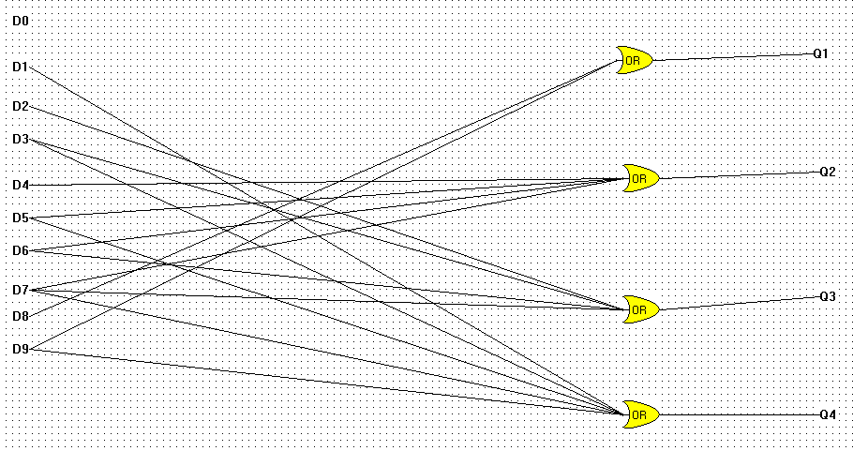

Session 2

Ex 10: Design Sequential Circuit of clocked RS flipflop with 4 NAND gates.

Ans:

http://www.play-hookey.com/digital/sequential/clocked_rs_latch.html

The circuit has R and S inputs and a clock input. This latch flip flop is activated by a positive level on the clock input.

If clock = 0, Output Q, Q`= Hold (nochange)
If clock = 1, R=0, S=1,Q=1 State = Set
If clock =1, R=1, S=0, Q`=1 State= Reset
If clock =1, R=0, S=0, State = Hold (no change)

Ex 11: Design Sequential Circuit of Clocked D flip flop with AND and NOR gates.

Ans:
A D-type latch is shown below.

The advantage of this is the single D input.
The flip flop takes the value at its D input whenever the clock pulse input is high it will effectively “track’ the input levels as long as the clock input is high.
If the clock input is zero, the state will be that of the last state the flipflop was when it was high.

Ex 13: Design Linear Feed-back Shift Register.

Ans:
A shift register with feedback consists of four flip-flops connected in a shift register configuration and feedback from these four flip-flops to the flip-flop’s inputs. This particular counter is started by setting 1 in X1 and 0s in X2, X3 and X4. The sequence of states is then
1 | 0 | 0 | 0
0 | 1 | 0 | 0
0 | 0 | 1 | 0
1 | 0 | 0 | 1
1 | 1 | 0 | 0
0 | 1 | 1 | 0
1 | 0 | 1 | 1
0 | 1 | 0 | 1
1 | 0 | 1 | 0
1 | 1 | 0 | 1
1 | 1 | 1 | 0
1 | 1 | 1 | 1
0 | 1 | 1 | 1
0 | 0 | 1 | 1
0 | 0 | 0 | 1
1 | 0 | 0 | 0
0 | 1 | 0 | 0

Notice that this sequence contains 15 of 16 possible 4 bit numbers that might be taken by that might be taken by this circuit. This is a widely used sequence which occurs in many instruments and has many uses in radar system, sonar system, coding encryption boxes, etc.

X1 | X2 | X3 | X4
1 | 0 | 0 | 0
0 | 1 | 0 | 0
0 | 0 | 1 | 0
1 | 0 | 0 | 1

1 | 1 | 0 | 0
0 | 1 | 1 | 0
1 | 0 | 1 | 1
0 | 1 | 0 | 1
1 | 0 | 1 | 0
1 | 1 | 0 | 1
1 | 1 | 1 | 0
1 | 1 | 1 | 1
0 | 1 | 1 | 1
0 | 0 | 1 | 1
0 | 0 | 0 | 1

In the counter table, the flip – flop names are first listed, flowed by the starting states. Then the successive states taken are listed in order, and the final line contains the state preceding the starting state.

Ex 14: Design a logical circuit that will calculate the less than for 2 bits...

Ans:
Step: 1 specification

This circuit compares two inputs of size 2- bits i.e. its range is (0-3) the output will be 1 if A<B else0

Input: 2 input bits
1 bit for A0
1 bit for A1
1 bit for B0
1 bit for B1

Output: 1 bit (either 0 or 1)

Step2: Truth table

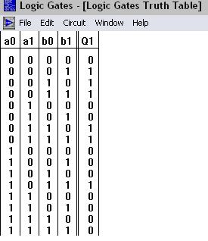
Step 3: Minterms and K-map

O1=F1 (1, 2, 3, 6, 7, 11)

Circuit:

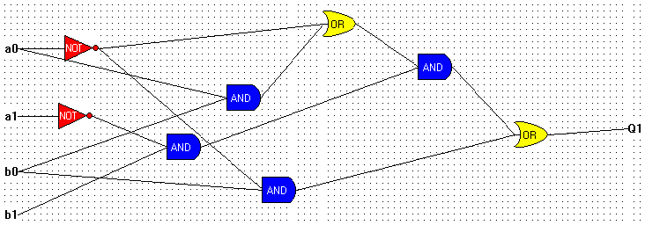

Ex 15: Design a multiplexer circuit that accepts N inputs and Outputs the value of one of those outputs.

Ans:
Multiplexing means transmitting a large number of information units over a smaller number of channels or lines. A digital multiplexer is a combination circuit that selects binary info from one of the many input lines and directs it to a single output line.

Circuit:
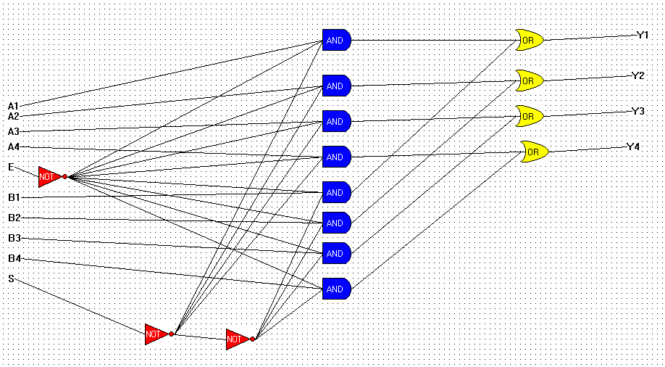

Ex 16: Design a decoder that has m inputs and 2^m outputs.

Ans: A decoder has the characteristic that for each possible 2^n input which can be taken by the n input cells, the matrix will have a unique one of its 2^n output lines selected.

